**Дата**: 20.05.2025

**Клас**: 3-АБ

**Предмет**: англійська мова

**Тема:** Контроль навичок читання.

**Мета:** : формувати навички вживання лексичних одиниць по темі; удосконалювати навички читання, аудіювання й усного монологічного мовлення; розвивати пізнавальні інтереси учнів; виховувати інтерес до самостійного пошуку потрібної інформації, а також загальну культуру учнів.

**Вчитель**: Руда Д.В.

Хід уроку

1.Greeting

Good afternoon, guys! I’m glad to see you. Are you ready to start our lesson? All set?

2. Wаrm up / Listening

Уважно слухати аудіо трек і дати відповідь на питання вчителя <https://www.youtube.com/watch?v=Zvp8_fT5mJQ> .

3. Speaking

What day is tomorrow?

What day is the day after tomorrow?

What day was it yesterday?

What day was the day before yesterday?

Which days of the week do you have an English class?

What is your last working day of the week?

What is your first working day of the week?

On which day do you start work again?

What day of the week is the hardest for you to spell?

What days of the week are the weekend?

What is the date today?

What was the date yesterday?

What will the date be tomorrow?

4. Повторення

**Irregular Verbs**

To see- saw-seen- бачити

To sell- sold-sold- (продавати)

To do-did-done(робити)

To come- came-come(приходити)

To go-went-gone(йти)

To tell-told-told(розповідати)

To find-found-found(знаходити)

To give-gave-given(давати)

To sleep – slept – slept (спати)

To write-wrote-written- писати

To steal-stole-stolen- вкрасти

To speak-spoke-spoken-говорити (володіти мовою)

5. Writing

Контроль навичок читання.

1. **Read the text. (Прочитайте текст.)**

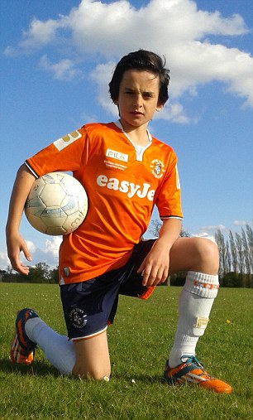This is my friend Tony, he is 11. He lives in Canada. But his grandparents live in Lutsk. Tony goes to school in Toronto.

Every day he gets up at 7 o’clock. He cleans his teeth, washes and dresses. At 7:30 he has his breakfast and goes to school.

Tony comes home at 2 o’clock and does his homework. He likes to play football and read, but he doesn’t like to play computer games.

Three months ago he visited his grandparents in Lutsk. I was very happy. We laughed a lot, watched films, went to the park and played hide-and-seek. He spent here 1 week. Then he came back to Canada.

1. **Choose a correct variant. (Оберіть правильний варіант.)**
2. Tony is ______.
3. Eleven;
4. Ten;
5. Twelve
6. My friend is from ______.
7. Canada;
8. The USA;
9. Ukraine.
10. Tony was in Lutsk ...
11. Three days ago;
12. Three weeks ago;
13. Three months ago.
14. Who lives in Lutsk?
15. Tony’s cousins;
16. Tony’s grandmother and grandfather;
17. Tony’s parents.
18. **Say if the sentences are TRUE or FALSE. (Вкажіть, які речення – правда, а які – брехня.)**
19. Tony gets up at half past six. ______
20. Tony doesn’t like to play computer games. _______
21. When Tony was in Ukraine, we went to the forest. ________
22. Tony spent one month in Lutsk. _________
23. **Complete the sentences. (Доповніть речення.)**
24. Tony gets up at ______ _______ ________.
25. I was very happy, when Tony came to Lutsk.
26. Tony doesn’t like to _________ _________ ________.
27. Tony visited his grandparents _________ __________ ago.

6. Vocabulary

To observe – спостерігати (обзьов)

To close- закрити(клоуз)

to decide- вирішувати (дісайд)

to kiss- поцілувати(кіс)

to agree- погодитися(егрі)

7. Homework

1. Виконати письмово вправу на past simple подану нижче.

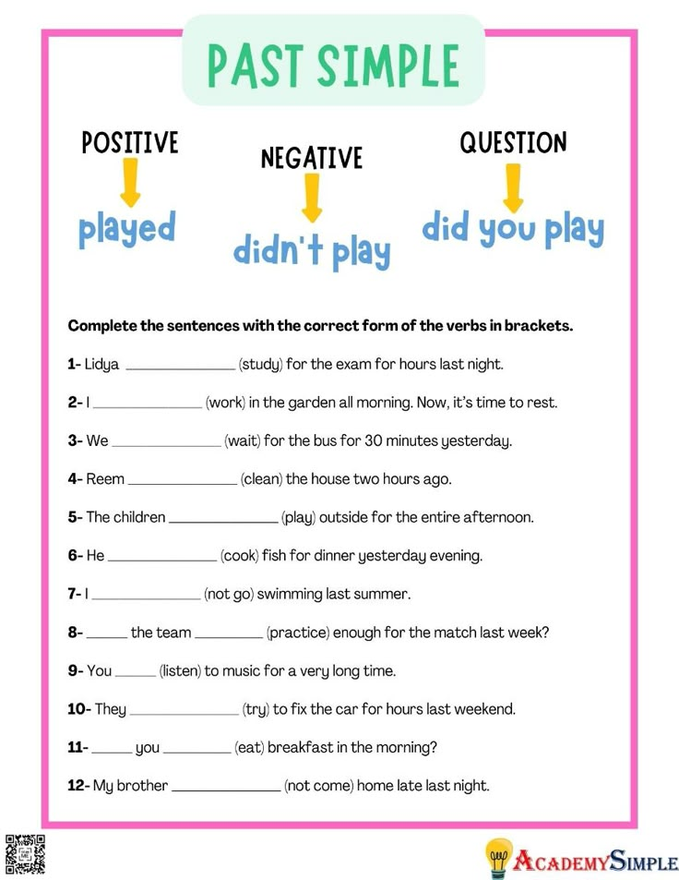

2. Вивчити неправильні дієслова в конспекті.